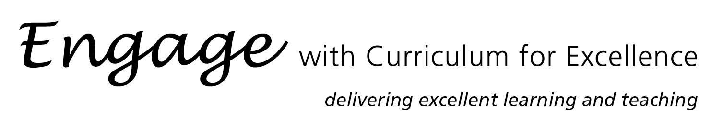

Projekt Langholm – Producing a flyer in German to advertise in tourism
Suitable for:
- S2/S3 pupils in Broad General Education
- S5 students in the CfE Higher German course
Time allocated:
Projekt Langholm in embedded in the S2/S3 and the CfE Higher German programme of study at Langholm Academy. Time allocation for producing the flyers on the computer is between four and five periods of 50 minutes.

Summary:
Pupils experience Projekt Langholm as part of the German courses in S2/3 and CfE Higher German. They learn about places in a town, they describe their hometown and learn to say what tourists can do in and around the area. The outcome of this learning process is a flyer in German to attract German speaking visitors to the town/the region.

Wider Achievement:
Engaging in Projekt Langholm allows learners to develop these skills:
- How to advertise/attract people to a product/a place
- How to use Microsoft Publisher (ICT skills)
- How to type a text in German (using two ways of inserting accents)
- How to use German in a vocational context
Projekt Langholm is a cross-curricular resource with links to:
- Geography
- History
- Travel and Tourism
- Business Management
- ICT



